Dear UC Davis Graduate & Professional Students:

The Cross Cultural Center (CCC) would like to invite you to apply as a mentee to our Graduate Students of Color (GSoC) Mentoring Program for the 2023-2024 academic year. The need to increase and improve faculty-graduate student mentorships within underrepresented groups was one key recommendation resulting from the Diversity Dialogues with the Dean in 2014. The GSoC Mentoring Program was created to address that recommendation.

Purpose of the GSoC Mentoring Program
Our primary goal is to assist in the retention of historically marginalized students in order to improve their representation in the UC Davis graduate community. We do this by providing graduate students of color structured opportunities to explore a variety of academic and career pathways. We believe that faculty mentorship of graduate students of color is imperative for their retention in their graduate programs at UC Davis and for increasing the number of faculty of color in the academy overall.

Format of the GSoC Mentoring Program
GSoC is a two-quarter commitment beginning in Winter 2024 and taking place through the end of Spring 2024. Graduate students will be paired with faculty mentors that are willing to share their experiences and offer helpful tips on how to successfully navigate graduate school at UC Davis, emphasizing issues for graduate students of color. While mentors and mentees will determine their agreed upon goals, we suggest that they meet between once and twice a month. These meetings are an opportunity for mentors and mentees to communicate their experiences in a more relaxed setting than traditional faculty-graduate student research-related advising.

Benefits of Participating in the GSoC Mentoring Program
Graduate Students who participate in the GSoC Program will be part of a community of like-minded graduate students and faculty members who are committed to the development and support of student-driven diversity initiatives here at UC Davis. Moreover, through their participation in the program, graduate students receive targeted support from the CCC network as they endeavor to meet their research and professional goals.

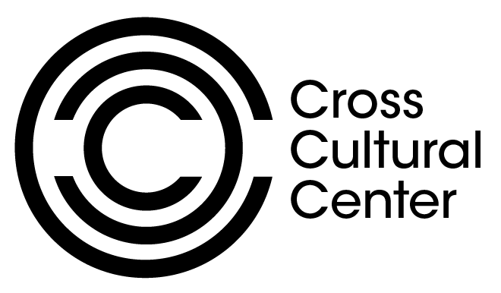
Applications close Dec 14th
Application Link

